I) **How to set-up SDL2 for your project:**

1. 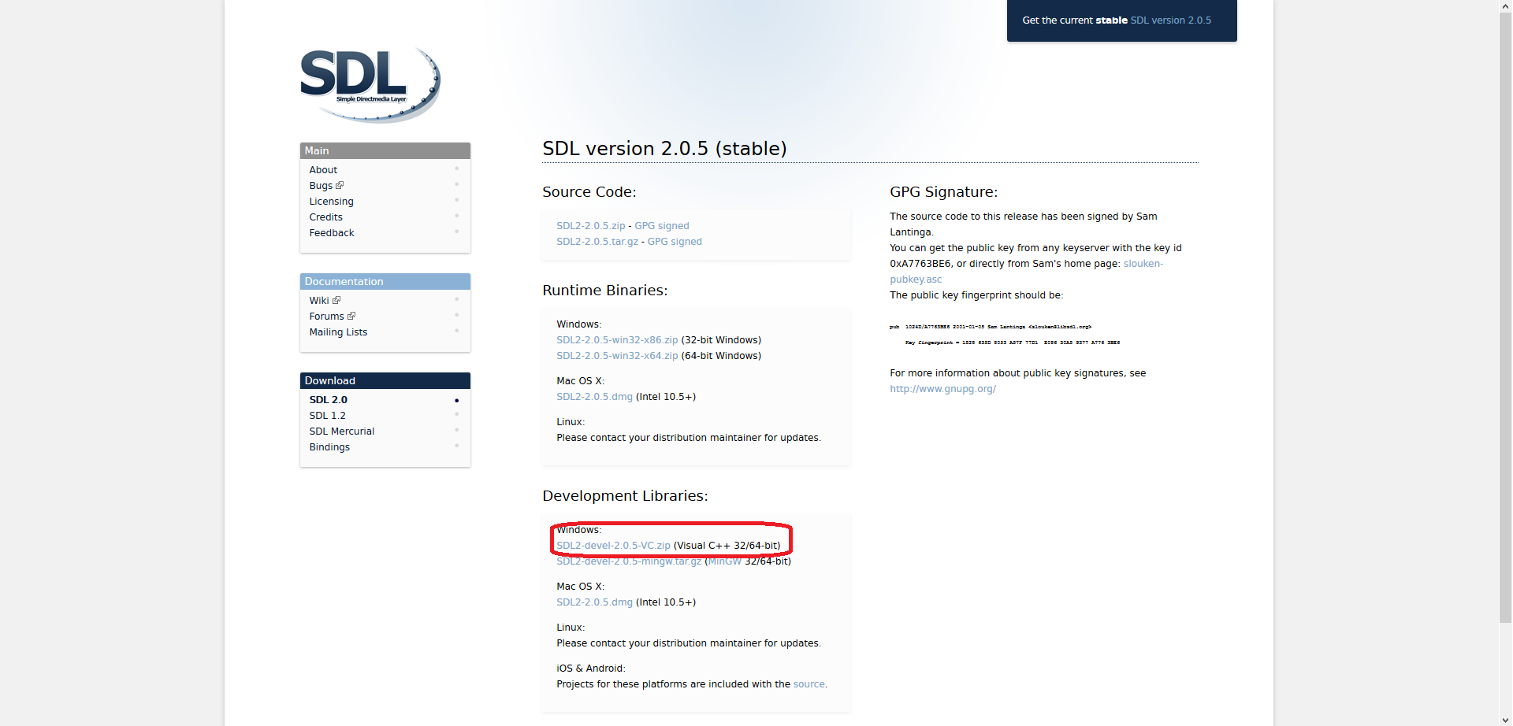Download SDL2 – <http://libsdl.org/download-2.0.php>
2. Extract SDL2-2.0.5 folder from the zip file somewhere convenient(it’s most convenient to put it in the project’s folder)
3. Copy file: SDL2.dll from the SDL2-2.0.5 -> lib -> x86 folder into your project’s Debug folder (where the .exe file is)
4. Go to your project’s properties:

* 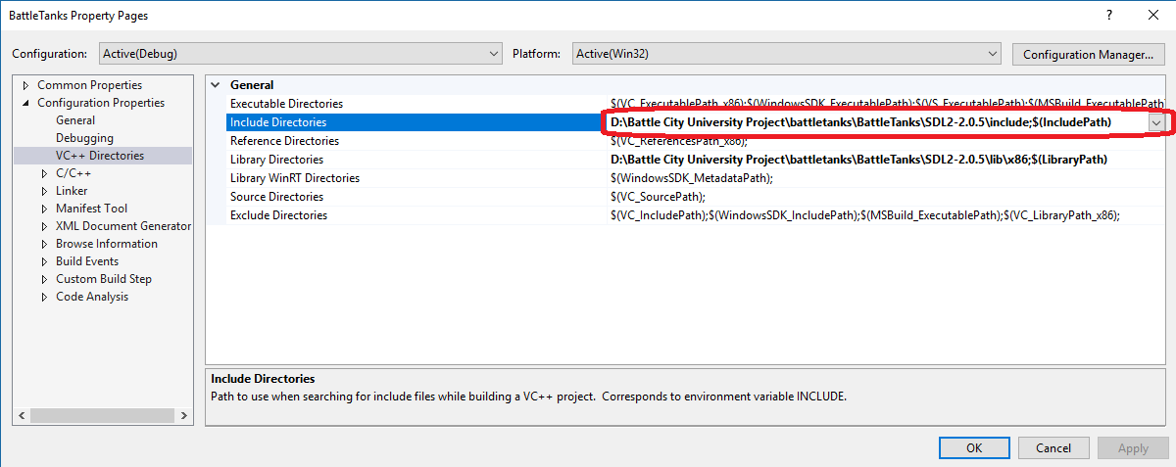Go to – Configuration Properties -> VC++ Directories -> Include Directories and select the path to the include folder in the SDL2-2.0.5 folder you have extracted previously:
* 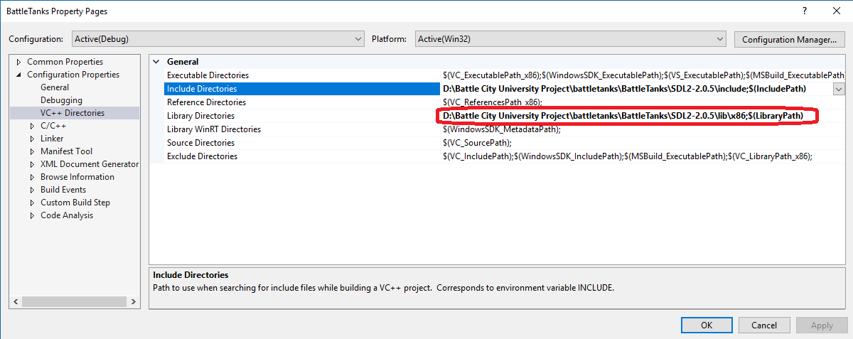Do the same thing for the Library Directories(use the x86 version):
* 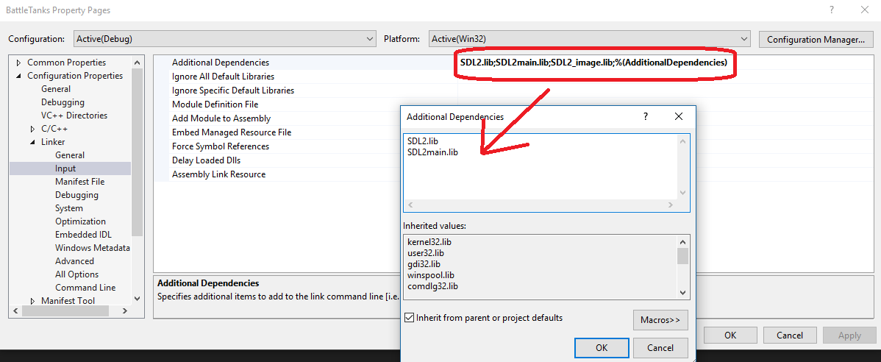Go to Configuration Properties -> Linker -> Input -> Additional Dependencies and add the SDL2.lib and the SDL2main.lib files:
* 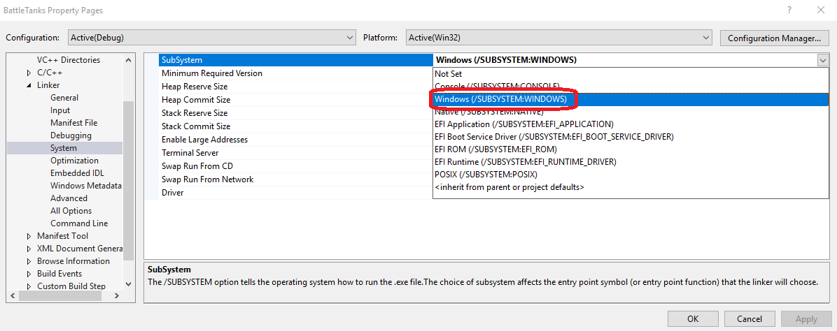Go to Configuration Properties -> Linker -> System -> SubSystem and choose SubSystem Windows:
* Click Apply -> OK and you are now set-up to use SDL2
* Do not forget to #include <SDL.h> where you need it in order to use it

**II) How to set-up SDL_Image for your project:**

1. 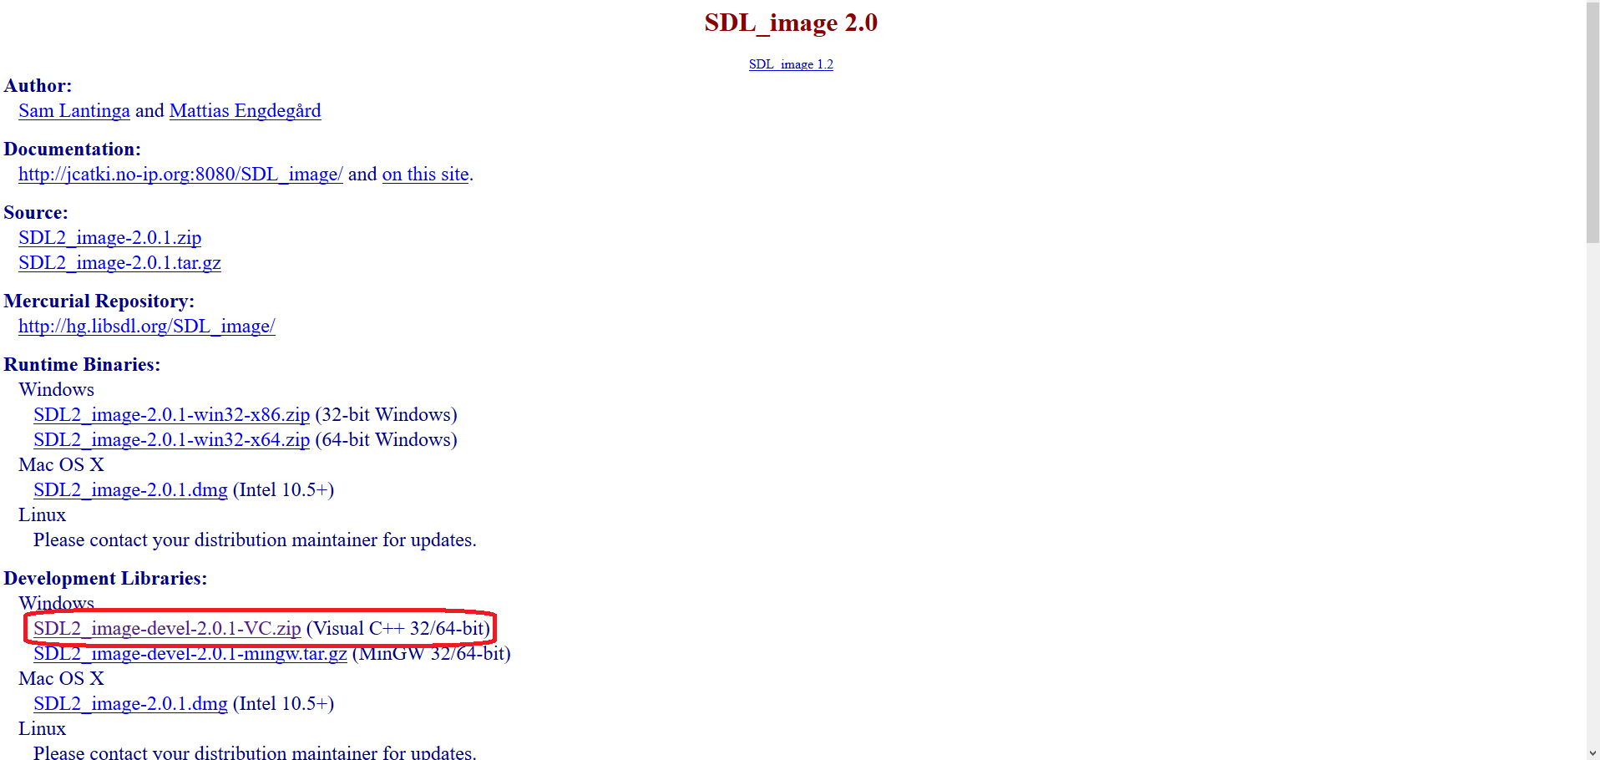Download SDL_image 2.0 - <http://libsdl.org/projects/SDL_image/>
2. Extract the SDL2_image-2.0.1 somewhere(not needed in your project folder)
3. Copy the SDL_image.h file from the SDL2_image-2.0.1 include folder and paste it in the include folder in your SDL2-2.0.5 folder
4. Copy all the files located in the lib -> x86 folder in the SDL2_image-2.0.1 folder into the lib -> x86 folder in your SDL2-2.0.5 folder
5. Copy files: libpng16-16.dll, SDL2_image.dll and zlib1.dll from the lib -> x86 folder in the SDL2_image-2.0.1 folder into the project’s Debug folder (where the .exe file is)
6. 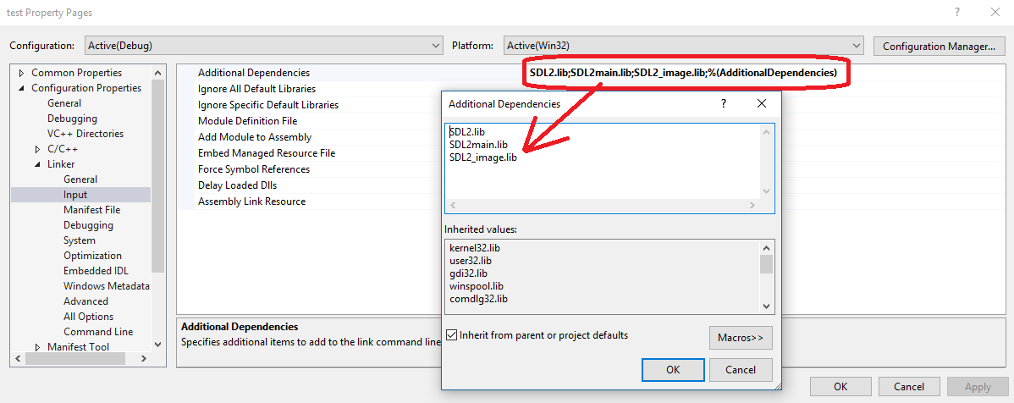Go to your project’s properties: Configuration Properties -> Linker -> Input -> Additional Dependencies and add the SDL2_image.lib file
7. Do not forget to #include <SDL_image.h> where you need in order to use it

**III) How to set-up tinyxml2 for your project:**

1. 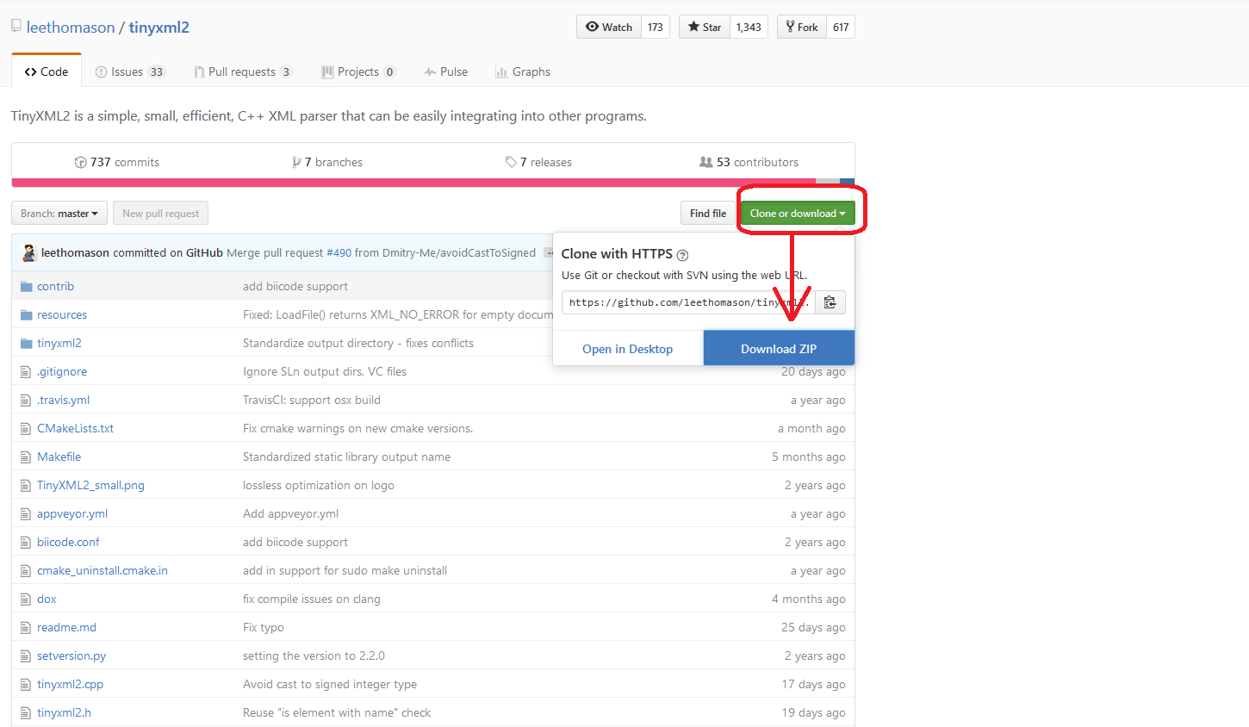Download the tinyxml2 zip: <https://github.com/leethomason/tinyxml2>
2. Extract the tinyxml2-master folder from the downloaded zip file
3. Copy files: tinyxml2.cpp and tinyxml2.h from the tinyxml2-master folder into your project folder(where all the .cpp and .h files are)
4. 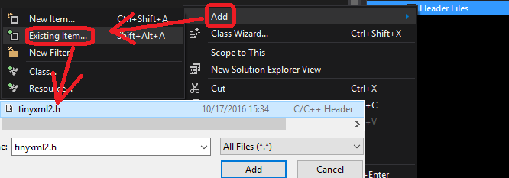Open your project in Visual Studio, go to Header Files, right click -> Add -> Existing Item and select/add the tinyxml2.h file you added in your project folder in step №3
5. 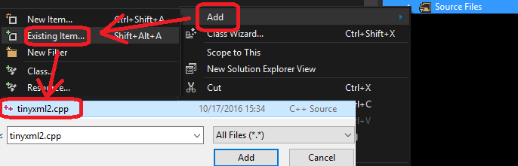Same thing for the source file. Instead of Header Files, select Source Files and select/add the tinyxml2.cpp file you added in your project folder in step №3
6. Do not forget to #include "tinyxml2.h" where you need it so you can use it. Also, for convenience(so you don’t have to write tinyxml2:: ….. every time) add (using namespace tinyxml2;) where you will use tinyxml2